DataImporter using Entity Framework 6

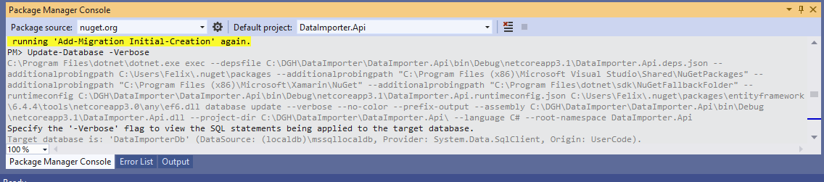

PM> **Enable-Migrations**

Checking if the context targets an existing database...

PM> **Add-Migration Initial-Creation**

Scaffolding migration 'Initial-Creation'.

The Designer Code for this migration file includes a snapshot of your current Code First model. This snapshot is used to calculate the changes to your model when you scaffold the next migration. If you make additional changes to your model that you want to include in this migration, then you can re-scaffold it by running 'Add-Migration Initial-Creation' again.

PM> **Update-Database -Verbose**

C:\Program Files\dotnet\dotnet.exe exec --depsfile C:\DGH\DataImporter\DataImporter.Api\bin\Debug\netcoreapp3.1\DataImporter.Api.deps.json --additionalprobingpath C:\Users\Felix\.nuget\packages --additionalprobingpath "C:\Program Files (x86)\Microsoft Visual Studio\Shared\NuGetPackages" --additionalprobingpath "C:\Program Files (x86)\Microsoft\Xamarin\NuGet" --additionalprobingpath "C:\Program Files\dotnet\sdk\NuGetFallbackFolder" --runtimeconfig C:\DGH\DataImporter\DataImporter.Api\bin\Debug\netcoreapp3.1\DataImporter.Api.runtimeconfig.json C:\Users\Felix\.nuget\packages\entityframework\6.4.4\tools\netcoreapp3.0\any\ef6.dll database update --verbose --no-color --prefix-output --assembly C:\DGH\DataImporter\DataImporter.Api\bin\Debug\netcoreapp3.1\DataImporter.Api.dll --project-dir C:\DGH\DataImporter\DataImporter.Api\ --language C# --root-namespace DataImporter.Api

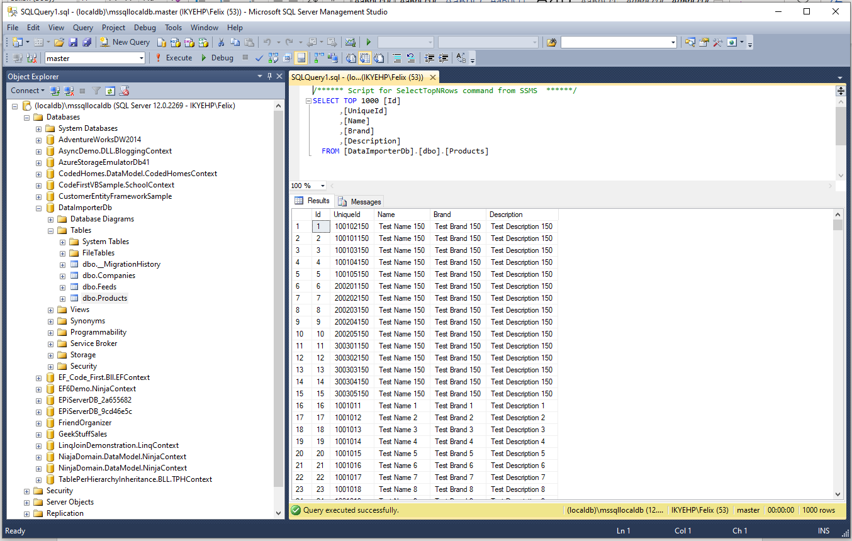

Specify the '-Verbose' flag to view the SQL statements being applied to the target database.

Target database is: 'DataImporterDb' (DataSource: (localdb)\mssqllocaldb, Provider: System.Data.SqlClient, Origin: UserCode).

Applying explicit migrations: [202104270751555_Initial-Creation].

Applying explicit migration: 202104270751555_Initial-Creation.

CREATE TABLE [dbo].[Companies] (

[Id] [int] NOT NULL IDENTITY,

[Name] [nvarchar](max),

[Path] [nvarchar](max),

[Product_Id] [int],

CONSTRAINT [PK_dbo.Companies] PRIMARY KEY ([Id])

)

CREATE INDEX [IX_Product_Id] ON [dbo].[Companies]([Product_Id])

CREATE TABLE [dbo].[Feeds] (

[Id] [int] NOT NULL IDENTITY,

[Name] [nvarchar](max),

[Path] [nvarchar](max),

[Product_Id] [int],

CONSTRAINT [PK_dbo.Feeds] PRIMARY KEY ([Id])

)

CREATE INDEX [IX_Product_Id] ON [dbo].[Feeds]([Product_Id])

CREATE TABLE [dbo].[Products] (

[Id] [int] NOT NULL IDENTITY,

[UniqueId] [nvarchar](max),

[Name] [nvarchar](max),

[Brand] [nvarchar](max),

[Description] [nvarchar](max),

CONSTRAINT [PK_dbo.Products] PRIMARY KEY ([Id])

)

ALTER TABLE [dbo].[Companies] ADD CONSTRAINT [FK_dbo.Companies_dbo.Products_Product_Id] FOREIGN KEY ([Product_Id]) REFERENCES [dbo].[Products] ([Id])

ALTER TABLE [dbo].[Feeds] ADD CONSTRAINT [FK_dbo.Feeds_dbo.Products_Product_Id] FOREIGN KEY ([Product_Id]) REFERENCES [dbo].[Products] ([Id])

CREATE TABLE [dbo].[__MigrationHistory] (

[MigrationId] [nvarchar](150) NOT NULL,

[ContextKey] [nvarchar](300) NOT NULL,

[Model] [varbinary](max) NOT NULL,

[ProductVersion] [nvarchar](32) NOT NULL,

CONSTRAINT [PK_dbo.__MigrationHistory] PRIMARY KEY ([MigrationId], [ContextKey])

)

INSERT [dbo].[__MigrationHistory]([MigrationId], [ContextKey], [Model], [ProductVersion])

VALUES (N'202104270751555_Initial-Creation', N'DataImporter.Api.Migrations.Configuration', 

Running Seed method.

PM> Enable-Migrations

Checking if the context targets an existing database...

PM> Add-Migration Initial-Creation

Scaffolding migration 'Initial-Creation'.

The Designer Code for this migration file includes a snapshot of your current Code First model. This snapshot is used to calculate the changes to your model when you scaffold the next migration. If you make additional changes to your model that you want to include in this migration, then you can re-scaffold it by running 'Add-Migration Initial-Creation' again.

PM> Update-Database -Verbose

C:\Program Files\dotnet\dotnet.exe exec --depsfile C:\DGH\DataImporter\DataImporter.Api\bin\Debug\netcoreapp3.1\DataImporter.Api.deps.json --additionalprobingpath C:\Users\Felix\.nuget\packages --additionalprobingpath "C:\Program Files (x86)\Microsoft Visual Studio\Shared\NuGetPackages" --additionalprobingpath "C:\Program Files (x86)\Microsoft\Xamarin\NuGet" --additionalprobingpath "C:\Program Files\dotnet\sdk\NuGetFallbackFolder" --runtimeconfig C:\DGH\DataImporter\DataImporter.Api\bin\Debug\netcoreapp3.1\DataImporter.Api.runtimeconfig.json C:\Users\Felix\.nuget\packages\entityframework\6.4.4\tools\netcoreapp3.0\any\ef6.dll database update --verbose --no-color --prefix-output --assembly C:\DGH\DataImporter\DataImporter.Api\bin\Debug\netcoreapp3.1\DataImporter.Api.dll --project-dir C:\DGH\DataImporter\DataImporter.Api\ --language C# --root-namespace DataImporter.Api

Specify the '-Verbose' flag to view the SQL statements being applied to the target database.

Target database is: 'DataImporterDb' (DataSource: (localdb)\mssqllocaldb, Provider: System.Data.SqlClient, Origin: UserCode).

Applying explicit migrations: [202104271047300_Initial-Creation].

Applying explicit migration: 202104271047300_Initial-Creation.

CREATE TABLE [dbo].[Companies] (

[Id] [int] NOT NULL IDENTITY,

[Name] [nvarchar](max),

[Path] [nvarchar](max),

[Product_Id] [int],

CONSTRAINT [PK_dbo.Companies] PRIMARY KEY ([Id])

)

CREATE INDEX [IX_Product_Id] ON [dbo].[Companies]([Product_Id])

CREATE TABLE [dbo].[Feeds] (

[Id] [int] NOT NULL IDENTITY,

[Name] [nvarchar](max),

[Path] [nvarchar](max),

[Product_Id] [int],

CONSTRAINT [PK_dbo.Feeds] PRIMARY KEY ([Id])

)

CREATE INDEX [IX_Product_Id] ON [dbo].[Feeds]([Product_Id])

CREATE TABLE [dbo].[Products] (

[Id] [int] NOT NULL IDENTITY,

[UniqueId] [nvarchar](max),

[Name] [nvarchar](max),

[Brand] [nvarchar](max),

[Description] [nvarchar](max),

CONSTRAINT [PK_dbo.Products] PRIMARY KEY ([Id])

)

ALTER TABLE [dbo].[Companies] ADD CONSTRAINT [FK_dbo.Companies_dbo.Products_Product_Id] FOREIGN KEY ([Product_Id]) REFERENCES [dbo].[Products] ([Id])

ALTER TABLE [dbo].[Feeds] ADD CONSTRAINT [FK_dbo.Feeds_dbo.Products_Product_Id] FOREIGN KEY ([Product_Id]) REFERENCES [dbo].[Products] ([Id])

CREATE TABLE [dbo].[__MigrationHistory] (

[MigrationId] [nvarchar](150) NOT NULL,

[ContextKey] [nvarchar](300) NOT NULL,

[Model] [varbinary](max) NOT NULL,

[ProductVersion] [nvarchar](32) NOT NULL,

CONSTRAINT [PK_dbo.__MigrationHistory] PRIMARY KEY ([MigrationId], [ContextKey])

)

INSERT [dbo].[__MigrationHistory]([MigrationId], [ContextKey], [Model], [ProductVersion])

VALUES (N'202104271047300_Initial-Creation', N'DataImporter.Api.Migrations.Configuration', 

Running Seed method.